TutoConnect Software Testing Document

Software Testing Document
  - Sprint 2
  - Section 7, Group 4 | Principles of Software Engineering
Document Type | Software Testing Document, Sprint 2
Testing Type | User Acceptance Testing
Testing Approach | Testers view all screens and verify that visible UI elements match what is expected. No backend or data entry is performed during the test. System and integration testing are not applicable to static prototypes.
Mockup Screens | Splash Screen, Sign In, Registration (role selector), Student Registration, Tutor Registration, Recover Password, OTP Entry, Update Password, Search Page, Filtered Results, Filter Popup, Language Dropdown, Subjects Dropdown, Study Level Dropdown, Side Menu
Roles Evaluated | Student, Tutor
Version | 2.0

Contents
TutoConnect Software Testing Document 1
Software Testing Document 1
Introduction 3
Purpose 3
Methods 3
Mockup Screens Referenced 3

Introduction

Purpose
This document records the User Acceptance Testing (UAT) conducted on the TutoConnect Sprint 2 prototype mockups. Sprint 2 covers dashboards for all three roles, tutor and student profiles, settings panel, and admin user management. All testing is performed by visually inspecting each screen and verifying that the correct elements are present.
System testing and integration testing are not conducted at this stage. These testing types require a live backend. For a static mockup prototype, UAT is the appropriate and sufficient testing method.

Methods
The tester opens the relevant mockup screen and observes what is visible. Each test case states which screen to observe, what elements should be visible based on user stories, and what was observed on the mockup. A pass means that all expected elements are present. A fail meants one or more required elements are missing from the mockup.

Mockup Screens Referenced
- Student Dashboard
- Tutor Dashboard
- Admin Dashboard
- Tutor Public Profile (About tab)
- Tutor Public Profile (Reviews tab)
- Student Profile
- Student Profile Edit
- Settings Panel
- Deactivation Confirmation Model
- Admin User Management
- Admin Deactivation Confirmation Model

Test ID | User Story | Mockup Screen | Expected Items | Visible Items | Status
1 | Student dashboard shows personalised content | Student Dashboard | Dashboard must show a welcome greeting with the student's name, a Saved Tutors section with tutor cards, an Upcoming Sessions section with at least one session card, and a Recommended Tutors section. | - Welcome greeting with the student's name  - Saved Tutors section with tutor cards  - Upcoming Sessions section with at least one session card  - Recommended Tutors section. | Pass
2 | Upcoming session card on student dashboard | Student Dashboard | Each session card must show: tutor name, subject, date and time, and a Join Session button. | Each session card shows:  - Tutor name  - Subject  - Date and time  - Join Session button. | Pass
3 | Tutor dashboard shows performance stats | Tutor Dashboard | Dashboard must show 4 KPI stat panels: Profile Views, Earnings (RM), Upcoming Sessions count, and Overall Rating. | Dashboard shows:  - Profile views  - Total earnings  - Upcoming sessions  - Overall rating | Pass
4 | Tutor availability grid on dashboard | Tutor Dashboard | An availability grid must be visible showing days of the week (Mon–Sun) against time slots (Morning, Afternoon, Evening). Free slots must appear in green, booked slots in grey. | Availability grid visible showing days of the week against time slots. Free slots are marked in green and booked slots are in grey. | Pass
5 | Tutor upcoming sessions list | Tutor Dashboard | A list of upcoming sessions must be visible, each showing student name, subject, date, and a status badge (Confirmed / Pending). | A list of upcoming sessions with  - Student name  - Subject  - Date  - Status badge (Confirmed / Pending). | Pass
6 | Admin dashboard KPI cards | Admin Dashboard | Dashboard must show 4 KPI cards: Total Users, Active Tutors, Monthly Sessions, Monthly Revenue. | Dashboard shows:  - Total Users  - Active Tutors  - Monthly Sessions  - Monthly Revenue | Pass
7 | Admin recent activity table | Admin Dashboard | A Recent Activity table must be visible showing columns: User, Role, Action, Date. | Recent Activity table with  - User  - Role  - Action  - Date | Pass
8 | Admin monthly bookings chart | Admin Dashboard | A bar chart showing monthly bookings for the last 6 months must be visible on the admin dashboard. | Bar chart shows 5 months | Fail
9 | Tutor public profile header | Tutor Public Profile | Profile header must show: avatar/initials, tutor name, subject tag, star rating and review count, price per hour, languages, and years of experience. | Profile header shows:  - Avatar  - Tutor name  - Subject tag  - Star rating  - Review count  - Price per hour  - Languages  - Years of experience | Pass
10 | Tutor profile action buttons | Tutor Public Profile (About tab) | A Book Session button and a Contact button must both be visible on the tutor public profile. | Book Session and Message buttons visible on tutor profile | Pass
11 | Tutor profile About and Reviews tabs | Tutor Public Profile (About tab) | About and Reviews tabs must be visible. On the About tab: bio text, subjects list, and languages list must be visible. | About and Reviews tabs are visible. About tab shows:  - Bio text  - Subjects list,  - Languages list must be visible. | Pass
12 | Tutor profile Reviews tab content | Tutor Public Profile (Reviews tab) | On the Reviews tab: review cards must be visible each showing student name, star rating, date, review text. A tutor reply section and a Reply button must be visible on at least one card. | Reviews tab shows:  - Review cards showing student name  - Star rating,  - Date  - Review text.  - Tutor reply section  - Reply button | Pass
13 | Student profile displays personal information | Student Profile | Student profile must show: avatar/initials, student name, level of studies tag, institution, bio, subjects, languages, and a session history table. | Student profile shows:  - Avatar/initials  - Student name  - Level of studies  - Institution  - Bio  - Subjects  - Languages  - Session history table. | Pass
14 | Student profile Edit Profile button | Student Profile | An Edit Profile button must be visible on the student profile screen. | Edit Profile button visible | Pass
15 | Student profile edit state | Student Profile Edit | In edit mode, all profile fields must become input fields. A Save Changes button and a Cancel button must both be visible. | All profile fields are input fields. Save Changes button and Cancel button are visible. | Pass
16 | Settings — account fields | Settings Panel | Settings screen must show: avatar with Change Photo button, Full Name field, Username field, Email field, Current Password, New Password, and Confirm New Password fields, and a Save Changes button. | Settings screen shows:  - Avatar  - Change Photo button  - Full Name field  - Username field  - Email field  - Current Password  - New Password  - Confirm New Password  - Save Changes button. | Pass
17 | Settings — preferences | Settings Panel | A Preferences section must show a Language dropdown and a Notifications toggle. | Preferences section shows:  - Language dropdown  - Notifications toggle | Pass
18 | Settings — privacy toggles | Settings Panel | A Privacy section must show a Profile Visible toggle and a Show Email toggle. | Privacy section shows:  - Profile Visible toggle  - Show Email toggle | Pass
19 | Settings — danger zone | Settings Panel | A Danger Zone section must be visible with a Deactivate Account button (red) | Danger Zone section visible with Deactivate Account button (red) | Pass
20 | Deactivation confirmation model | Deactivation Confirmation Model | A confirmation model must appear with a warning message, a red Confirm button, and a Cancel button. | Confirmation model  - Warning message  - Red confirm button  - Cancel button | Pass
21 | Language preference dropdown options | Settings Panel — Language dropdown open | The language dropdown must show at least: English, Malay, Chinese, French, Spanish, and a More option. | Language dropdown shows:  - English  - Spanish  - Chinese  - French  - Spanish  - More | Fail
22 | Admin user management table | Admin User Management | A user table must be visible with columns: Name, Email, Role, Status, Join Date, Actions. | User table visible with:  - Name  - Email  - Role  - Status  - Join Date  - Actions. | Pass
23 | Admin user search and filters | Admin User Management | A search bar, a Role filter dropdown (All / Student / Tutor / Admin), and a Status filter dropdown (All / Active / Pending / Inactive) must all be visible above the user table. | - Search bar  - Role filter dropdown (All/Student/Tutor/Admin)  - Status filter dropdown (All/Active/Pending/Inactive)  are all visible above the user table | Pass
24 | Admin approve tutor action | Admin User Management | An Approve button (green) must be visible in the Actions column for users with Pending status. | Approve button (green) visible in Actions column for users with Pending status. | Pass
25 | Admin deactivate user action | Admin User Management | A Deactivate button (red) must be visible in the Actions column for Active users. | Deactivate button (red) visible in Actions column for Active users. | Pass
26 | Admin deactivation confirmation model | Admin Deactivation Confirmation Model | A confirmation model must show the user's name, a warning message, a red Confirm button, and a Cancel button. | Deactivate button non-functional. | Fail

Test IDs | Image
1, 2 | 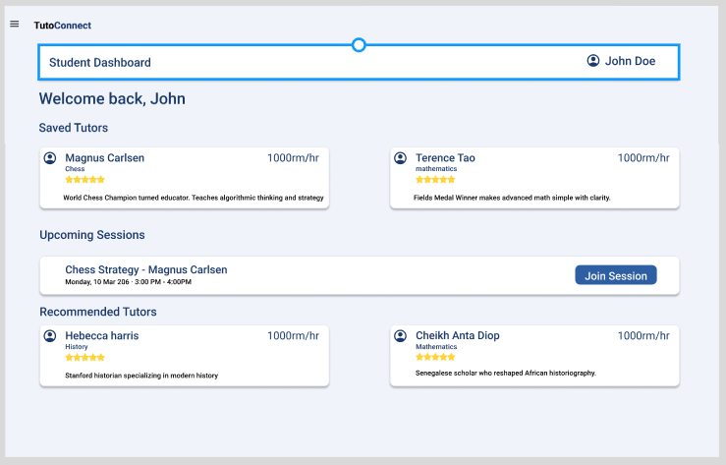
3, 4, 5 | 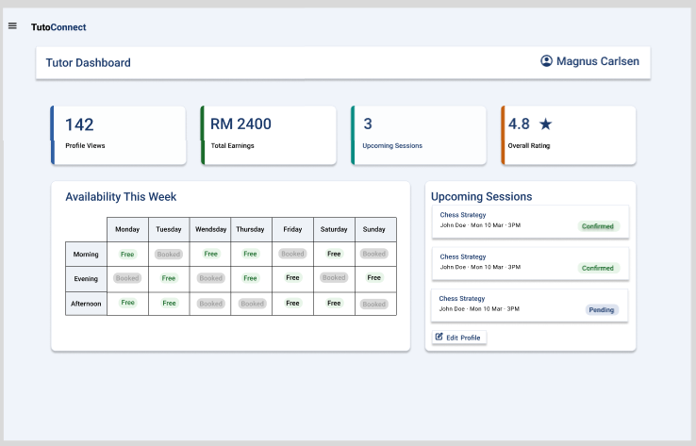
6, 7, 8 | 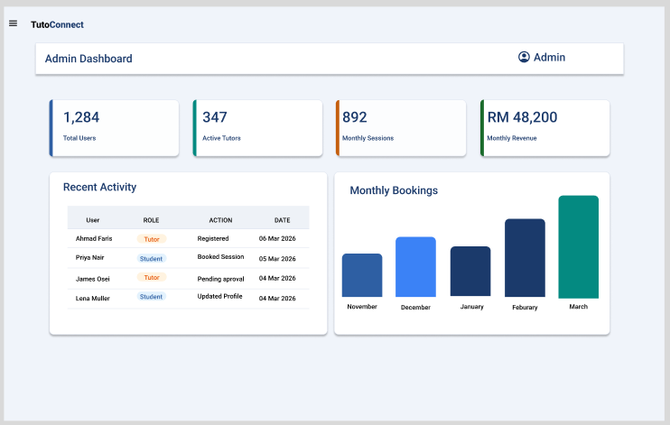
9, 10, 11 | 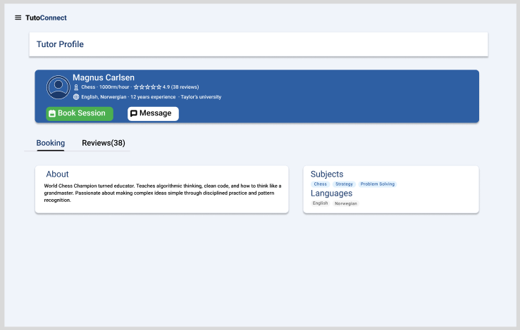
12 | 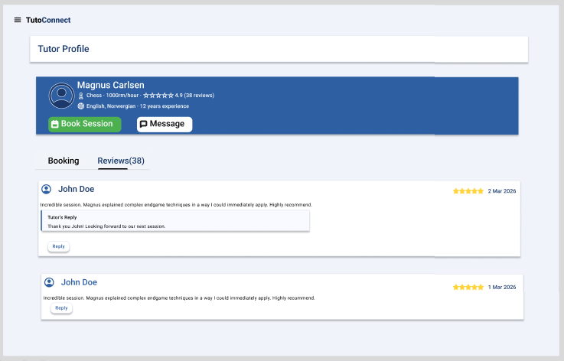
13, 14 | 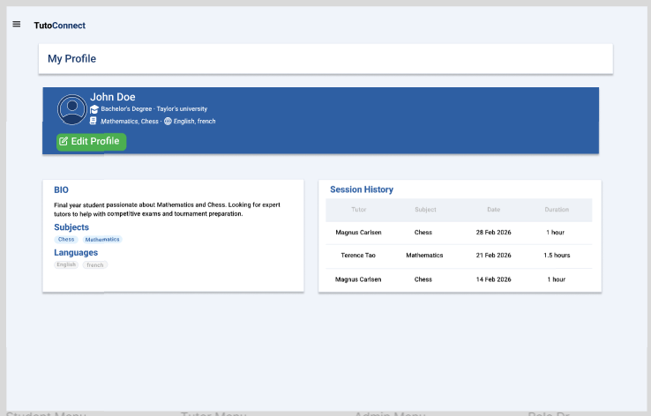
15 | 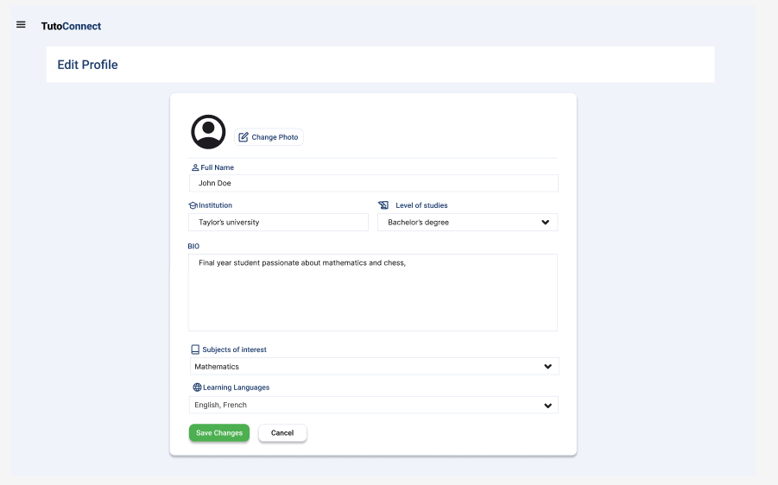
16, 17, 18, 19 | 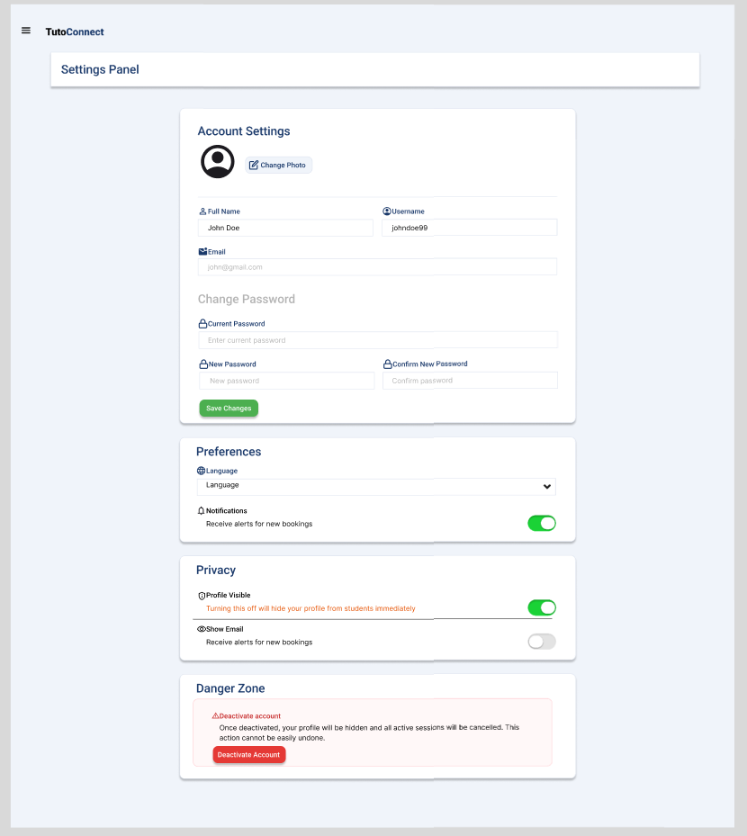
20 | 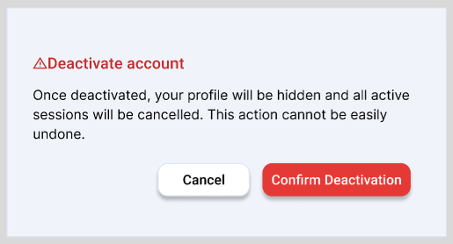
21 | 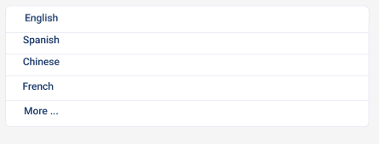
22, 23, 24, 25 | 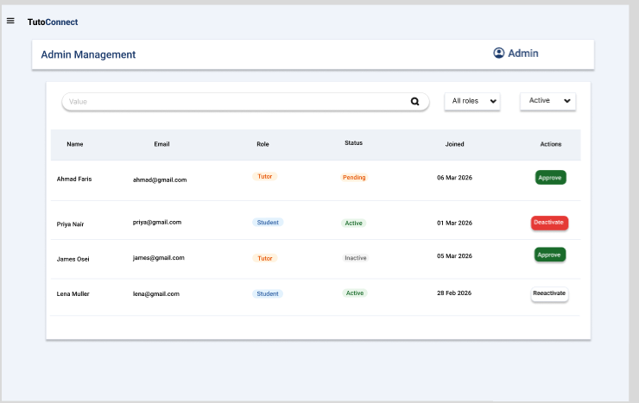

User Feedback

Collection Method
User feedback was collected using the feedback form distributed by Google Forms. Participants were asked to walk though the Sprint 2 prototype screens and answer questions covering dashboards, profiles and settings. The form was shared with participants after they reviewed the Sprint 2 mockup screens. All responses are recorded in the feedback form using Google Forms. This is the link for the feedback form

Responses
